**JDBC Sampler Script:**

In test plan-right click-add-thread –thread group

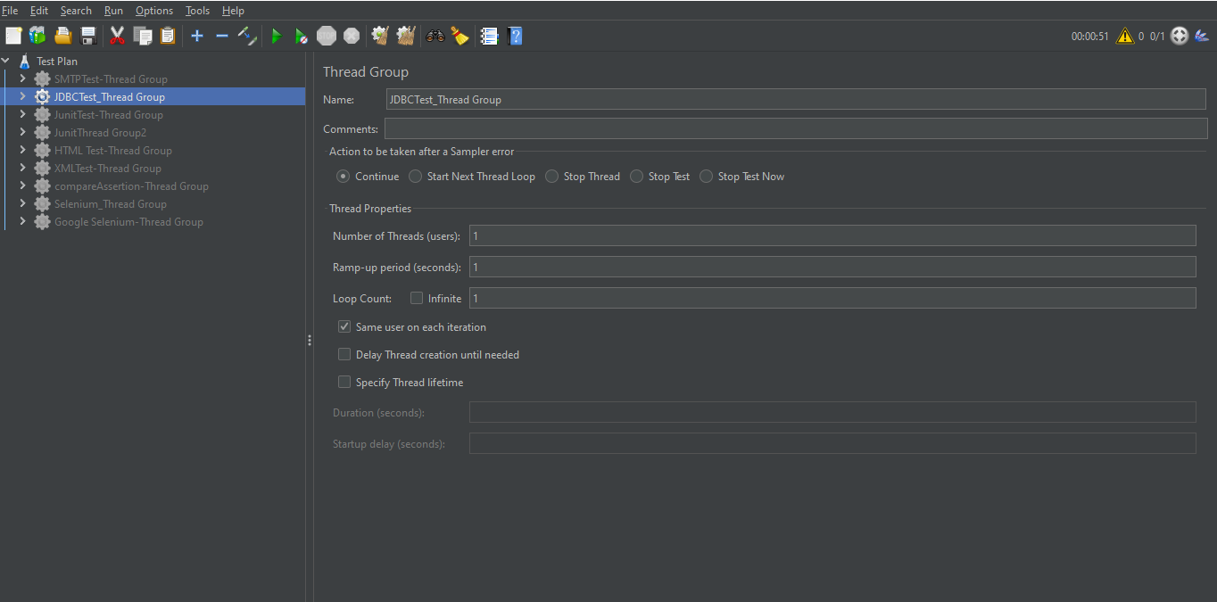

Download the JDBC connector jar file,Zip file will be downloaded.

Now go to downloads folder of lab and right click on zip file and click on extract here,In the folder there will be a JDBC connector.jar file.

This Jar file has to be copied and pasted in your Jmeter folder lib folder.

After copying the jar file in LIB folder→ restart your Apache Jmeter (close it and start it again).

In JMeter-create a Thread group - Add -Config Element-JDBC connection Configuration

Add the variable pool name and add DB connection details.

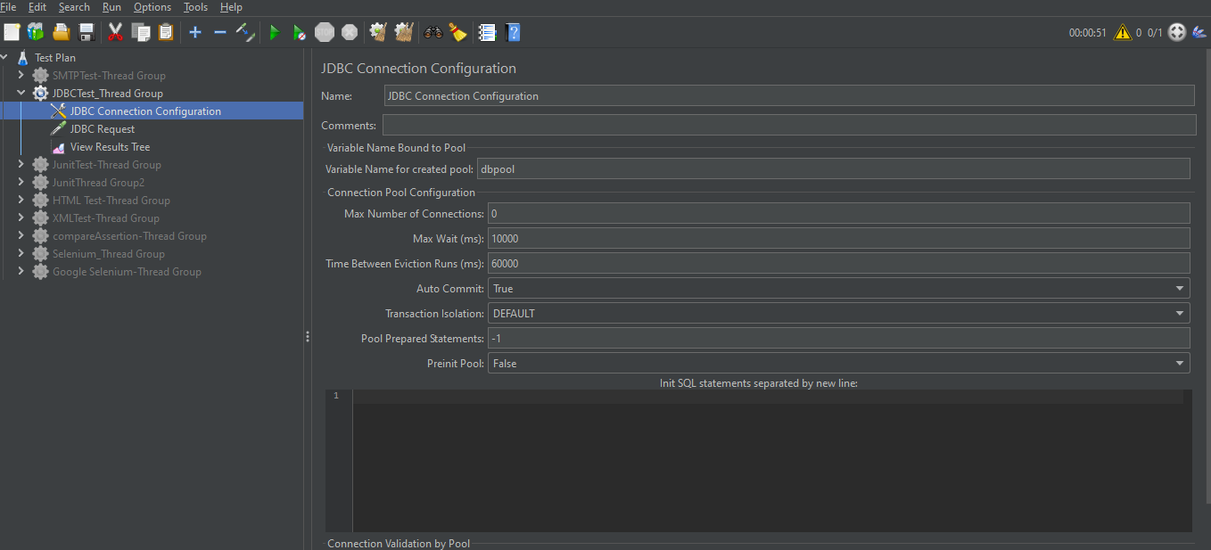

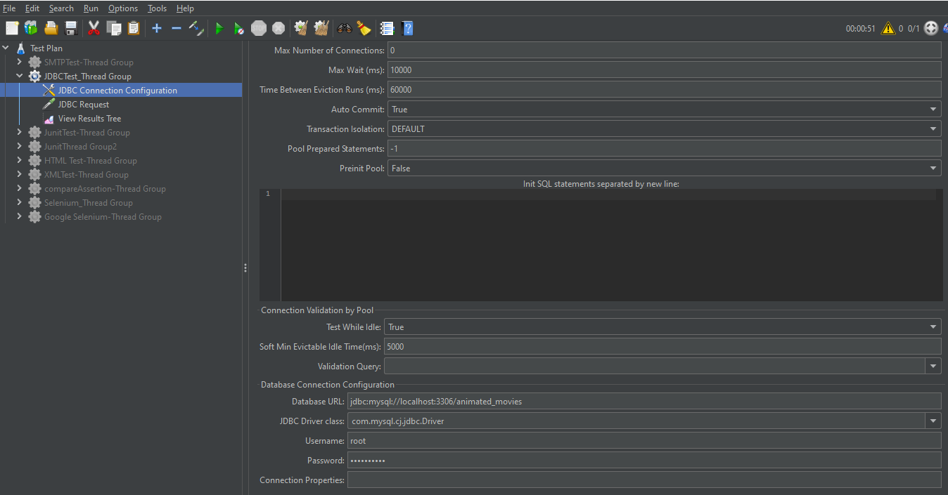

Thread group àAdd the JDBC request à Add the variable name as given in JDBC configurationà Add the query to be executed.

